The Patriarchs from the book of Genesis Part 21 – February 4, 2024
With input from https://www.bibleref.com/Genesis25
The Genesis Record by Henry Morris pages 240-245, 408; https://wake-up.org/bible-characters/esau-jacob-story.html

Last week we saw that Abraham remarried and had six more sons before his death is announced in verses 7 and 8. We discussed some of the lineage of Abraham and the lineage of Isaac that eventually produced King David and generations later, Jesus.

Gensis 25:1-6: Now Abraham took another wife, whose name was Keturah. 2 She bore to him Zimran, Jokshan, Medan, Midian, Ishbak, and Shuah. 3 Jokshan fathered Sheba and Dedan. And the sons of Dedan were Asshurim, Letushim, and Leummim. 4 The sons of Midian were Ephah, Epher, Hanoch, Abida, and Eldaah. All of these were the sons of Keturah.

This verse lists the sons of Midian, one of Abraham's six sons with Keturah. The Midianites became a well-known people group and played a role in the history of Israel. Apparently occupying the deserts around Israel, Midianite traders would later sell Joseph to Potiphar in Egypt (Genesis 37:36). Moses would marry Zipporah, the daughter of a Midianite man named Reuel (Exodus 2:20–21), also known as Jethro (Exodus 18:1–4). Unfortunately, the Midianites would eventually become another of Israel's enemies in the region.

Henry Morris: The few intimations of the names of the sons of Keturah that have appeared in the archaeological inscriptions do seem to confirm that statement of verse 6 that they were sent by Abraham into the east country, which would mean into Arabia. Through millennia of migrations and intermarriages, it seems likely that all of these peoples, together with the descendants of Ishmael, Lot, and Esau, along with earlier descendants of Shem and, in some cases, Ham, have gradually merged and become the modern-day Arabic peoples.

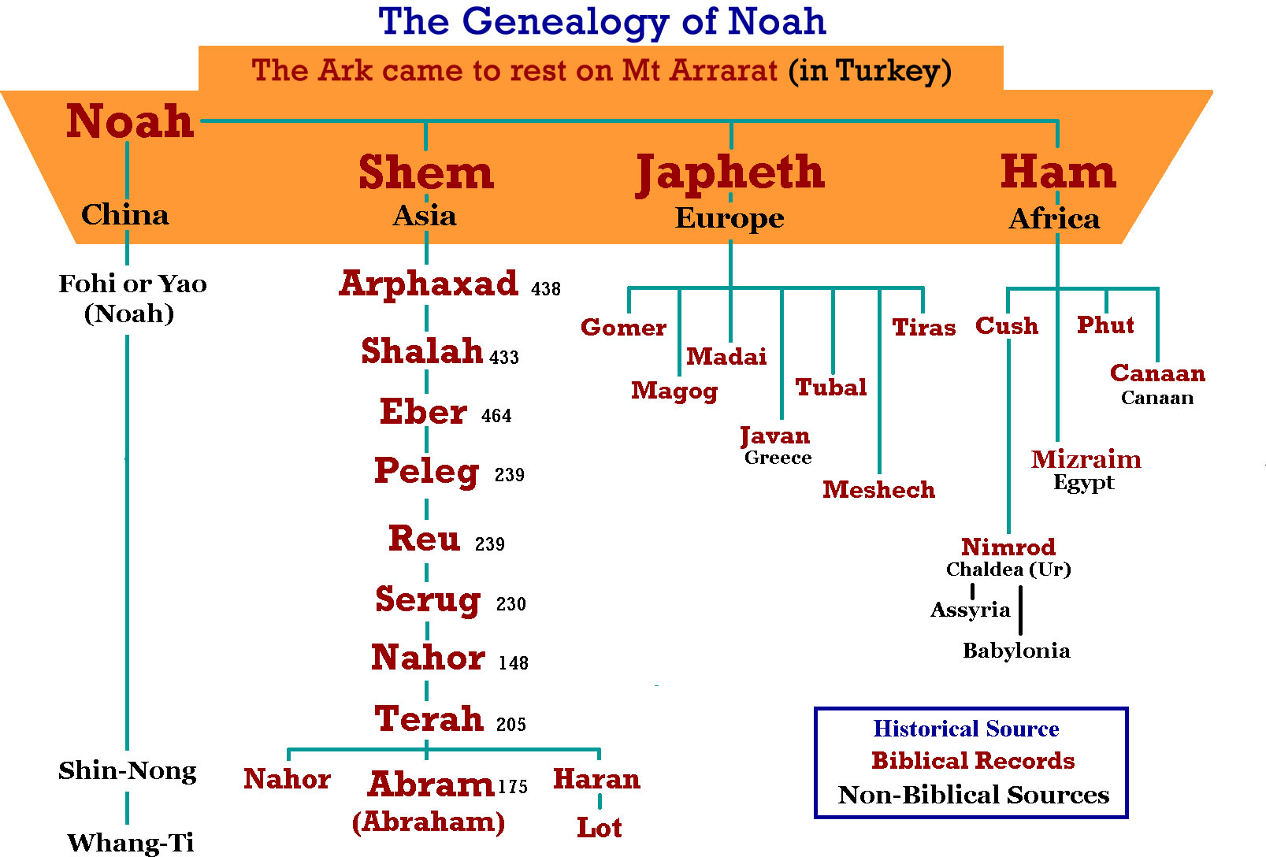

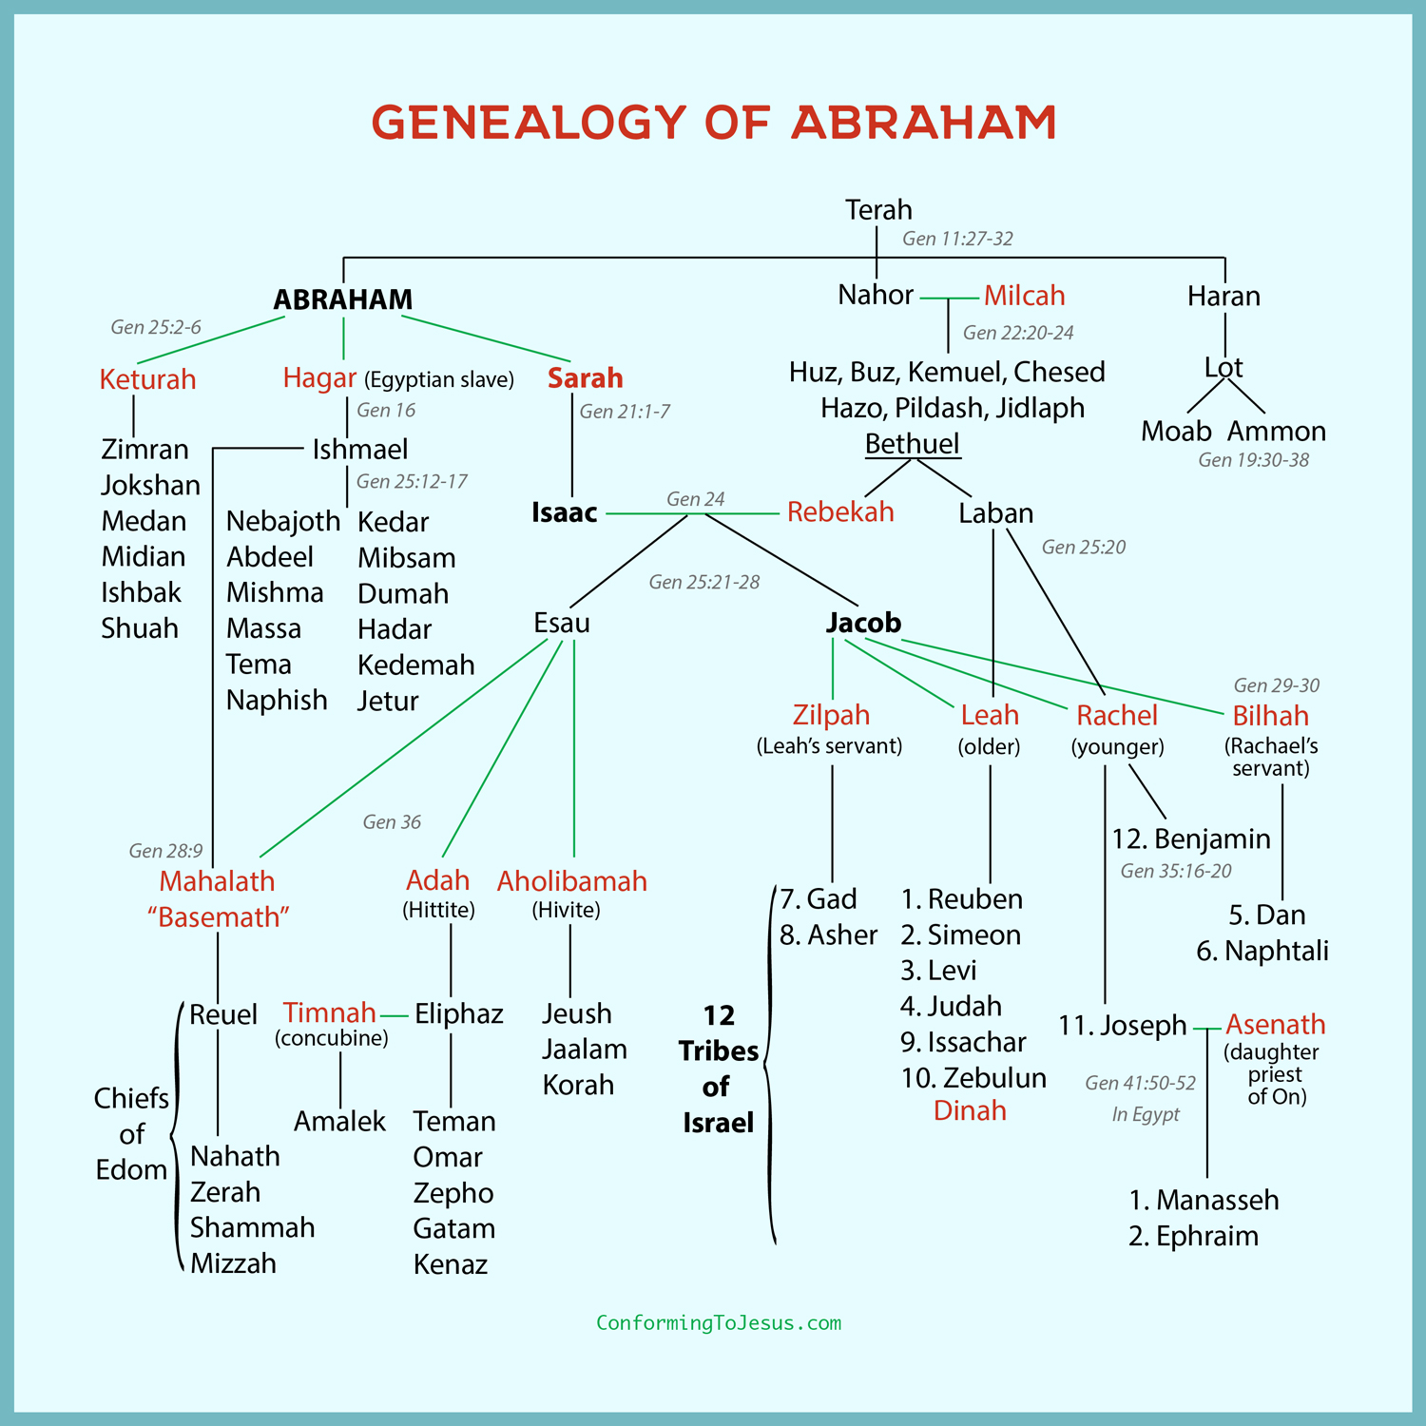

Old records clearly link the north Arabians with Ishmael’s descendants” (“Ishmael and the Bible,” Emmaus Journal 13:2, 2004). But it’s unlikely that all of those in Arabia are descendants of Ishmael, as the descendants of Keturah and the children of Esau also lived in the Arabian Peninsula.

17 These are the years of the life of Ishmael, 137 years; and he breathed his last and died, and was gathered to his people. 18 They settled from Havilah to Shur which is east of Egypt going toward Assyria; he settled in defiance of all his relatives.

Henry Morris: Out of which of Noah’s three sons did the Chinese race come from?

Descendants of Ham included the Egyptians and Sumerians, who founded the first two great empires of antiquity, as well as other great nations such as the Phoenicians, Hittites, and Canaanites. The modern African tribes and the Mongol tribes (including today the Chinese and Japanese), as well as the American Indians and the South Sea Islanders, are probably dominantly Hamitic in origin.

Genesis 9:26: And he (Noah) said, Blessed be the Lord God of Shem, and Canaan shall be his servant. Among the many ways in which the Hamites have been the great “servants” of mankind are the following:

(1) They were the original explorers and settlers of practically all parts of the world, following the dispersion at Babel.

(2) They were the first cultivators of most of the basic food staples of the world, such as potatoes, corn, beans, cereals, and others, as well as the first ones to domesticate most animals.

(3) They developed most of the basic types of structural forms and building tools and materials.

(4) They were the first to develop most of the usual fabrics for clothing and the various sewing and weaving devices.

(5) They discovered and invented a wide variety of medicines and surgical practices and instruments.

(6) They invented most of the concepts of basic practical mathematics, as well as surveying and navigation.

(7) The machinery of commerce and trade-money, banks, postal systems, and so forth—was developed by them.

(8) They developed paper, ink, block printing, movable type, and other accouterments of writing and communication.

If one traces back far enough, he will find that practically every other basic device or system needed for man’s physical sustenance or convenience originated with one of the Hamitic peoples. Truly they have been the “servants” of mankind in a most amazing way.

The Biblical mention of a people in the Far East named “Sinim” (Isaiah 49:12), together with references in ancient secular histories to people in the Far East called “Sinae,” at least suggests the possibility that some of Sin’s descendants migrated eastward, while others went south into the land of Canaan. It is significant that the Chinese people have always been identified by the prefix “Sino-” (e.g., Sino-Japanese War; Sinology, the study of Chinese history). The name “Sin” is frequently encountered in Chinese names in the form “Siang” or its equivalent.

The evidence is tenuous but, of all the names in the Table of Nations, it does seem that two sons of Canaan, Heth (Hittites = Khittae = Cathay) and Sin (Sinites = Sinim = China), are the most likely to have become ancestors of the Oriental peoples. Since it seems reasonable that divine inspiration would include in such a table information concerning the ancestry of all the major streams of human development, it is reasonable to conclude that the Mongoloid peoples (and therefore also the American Indians) have come mostly from the Hamitic line.

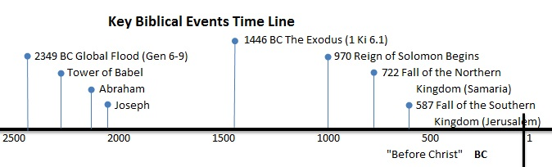

The next major section of Genesis actually begins in the middle of chapter 25, verse 19, with the “generations of Isaac”

Isaac’s Sons
Genesis 25:19-34: Now these are the records of the generations of Isaac, Abraham’s son: Abraham fathered Isaac; 20 and Isaac was forty years old when he took Rebekah, the daughter of Bethuel the Aramean of Paddan-aram, the sister of Laban the Aramean, to be his wife.

21 Isaac prayed to the Lord on behalf of his wife, because she was unable to have children; and the Lord answered him, and his wife Rebekah conceived. 22 But the children struggled together within her; and she said, “If it is so, why am I in this condition?” So she went to inquire of the Lord. 23 And the Lord said to her,

“Two nations are in your womb;
And two peoples will be separated from your body;
And one people will be stronger than the other;
And the older will serve the younger.”

24 When her days leading to the delivery were at an end, behold, there were twins in her womb. 25 Now the first came out red, all over like a hairy garment; and they named him Esau. 26 Afterward his brother came out with his hand holding on to Esau’s heel, so he was named Jacob; and Isaac was sixty years old when she gave birth to them.

27 When the boys grew up, Esau became a skillful hunter, a man of the field; but Jacob was a civilized man, living in tents. 28 Now Isaac loved Esau because he had a taste for game; but Rebekah loved Jacob.

Outline of Genesis 25:19-28: Jacob and Esau, the Children of Isaac:
- Rebekah, Isaac’s wife, was barren, so Isaac prayed for her.
- The Lord heard Isaac’s prayer and Rebekah conceived twins.
- The Lord said to her, “Two nations are in your womb, and two peoples from within you shall be divided; the one shall be stronger than the other, the older shall serve the younger.”
- The firstborn was named Esau and the second child, who came out grasping the heal of his brother, was named Jacob.
- Isaac loved Esau but Rebekah loved Jacob.

Genesis 25:29-34: When Jacob had cooked a stew one day, Esau came in from the field and he was exhausted; 30 and Esau said to Jacob, “Please let me have a mouthful of that red stuff there, for I am exhausted.” Therefore he was called Edom by name.

31 But Jacob said, “First sell me your birthright.” 32 Esau said, “Look, I am about to die; so of what use then is the birthright to me?” 33 And Jacob said, “First swear to me”; so he swore an oath to him, and sold his birthright to Jacob. 34 Then Jacob gave Esau bread and lentil stew; and he ate and drank, and got up and went on his way. So Esau despised his birthright.

Application:

- Esau’s decision to sell his birthright is not spoken of highly in the scriptures. Genesis 25:34 says, “Esau despised his birthright” and Hebrews 12:16 rebukes Esau for his poor decision.
- Esau was a fool because he traded a great blessing for something of little value. - Do we do the same thing? We want something “now” and are willing to give up the greater blessing?
- When people “despise” God’s offer of salvation because they don’t want to give up petty earthly pleasures, they are making a terrible trade.
- Esau grew to regret his decision to trade, and others will too if they trade an eternity with God for a few years of earthly fun.

Esau cared so little for the birthright that belonged to him because he loved the open country; he was a born explorer. He wanted to go where no one else had gone. Esau possessed the mind of a hunter/warrior. Esau was much like those who would come after him in history like Leif Erikson, Christopher Columbus, Daniel Boone, Meriwether Lewis, and William Clark gifted men who were determined to discover the length and breadth of the world. Esau was not content to be confined to a homestead and a garden.

He was not interested in tending sheep. He was not interested in settling down and becoming the spiritual leader of a nation. Esau was a free spirit who truly loved to roam the earth, and his father, Isaac, who grew up tending sheep and taking care of the home place admired the bold and adventuresome spirit of his firstborn son, Esau.

Rebekah loved Jacob because he was a “mother’s boy.” Jacob lived in the shadow of his stronger brother. Esau was physically agile, skilled in the use of weapons, and clever as a wilderness survivor/hunter. Jacob was studious and content to live “among the tents.”

As he began to understand the covenant which God had given his grandfather, Abraham, Jacob coveted the birthright that he had missed by a few measly seconds! Jacob had a heart for God. He was aware of the prophecy God gave Rebekah, but he could not figure out how “the older will serve the younger.” He could only wait upon the Lord. As far as Rebekah was concerned, she favored Jacob. She wanted Isaac’s birthright passed on to Jacob because she knew that Jacob was a spiritual man, a man who loved God.

In spite of what many people think, the Bible does not indicate that Esau was an evil man although he did have some missteps. When Esau was forty, he went against his parents wishes and married two Canaanites. (Genesis 26:34) While Esau was entitled to Isaac’s birthright (and the responsibilities that went with the birthright), he did not care for it.

However, he did want his father’s blessing. Esau and Isaac were very close and Isaac intended to bestow the birthright blessing upon Esau before he died (Genesis 27:4). I am sure that Isaac would not have done this if he thought Esau was not worthy of the birthright.

Esau and Jacob had serious character flaws (don’t we all?). Esau shirked his responsibilities as Isaac’s firstborn and he showed no interest in the covenant God gave to Abraham. On the other hand, mild-mannered Jacob was greedy, a liar, and a sneaky cheat. It is interesting to see how Jacob’s dishonesty and Esau’s indifference intersected. When Esau came in from a hunt that produced nothing, Jacob leveraged the birthright out of Esau. Jacob’s greed enabled him to take advantage of his brother.

His act was despicable and evil in God’s sight. (Leviticus 25:17; Deuteronomy 24:14–15) Esau, who regarded the obligations of his birthright as an unnecessary burden, let them go for a bowl of lentils. Esau was not worried because (a) he was much closer to his father than Jacob, and (b) both men knew that to make the birthright transfer legitimate, there was another hurdle their father’s approval and blessing.

One day, Rebekah overheard Isaac (who was blind) tell Esau to go on a hunt. Isaac wanted a tasty meal of wild game so that he could pronounce the birthright blessing upon Esau before he died. Rebekah raced to Jacob’s tent with a plan and Jacob’s greed caused him to conspire with his mother to steal Esau’s blessing so that the birthright transfer could be consummated.

This fact may surprise you, but Esau and Jacob were seventy years old. (Note: As I calculate it, Jacob was about 70 years old when he deceived his father, Isaac. Here is the evidence: (a) Jacob was 130 years old when he moved into Egypt. (b) Joseph was 39 or 40 when his father moved into Egypt. (Genesis 41:46,48; 45:4–6) (c) Joseph was born during Jacob’s twentieth year with Laban (Genesis 30:25; 31:38). So, 130 minus 40 minus 20 equals 70.)

Concerning the birthright: If two children made such a lopsided deal these days, it's likely a parent would step in and reverse the trade, giving each child a stern talking to. But the deal made between these two full-grown men will stand, as we'll see in the following chapters. The swearing of an oath, in that era, was as binding as the signing of a modern written contract.

The chapter ends with what appears to be an obvious statement. Esau "despised" his birthright. He didn't hold it with the value it was worth, and did not take care to protect it. This choice will carry consequences for the rest of his life, and even into history:

Hebrews 12:16-17: See that no one is sexually immoral, or is godless like Esau, who for a single meal sold his inheritance rights as the oldest son. 17 Afterward, as you know, when he wanted to inherit this blessing, he was rejected. Even though he sought the blessing with tears, he could not change what he had done.

