The Patriarchs from the book of Genesis Part 25 – March 17, 2024
With input from https://www.bibleref.com/Genesis30; https://www.workingpreacher.org/commentaries/revised-common-lectionary/ordinary-17/commentary-on-genesis-2915-28-5; https://www.thewarehouse.blog/genesis-29/

Last time we ended with Jacob being on the receiving end of being cheated.

Genesis 29:25 So it came about in the morning that, behold, it was Leah! And he said to Laban, “What is this that you have done to me? Was it not for Rachel that I served with you? Why then have you deceived me?”

Genesis 29:26 But Laban said, “It is not the practice in our place to marry off the younger before the firstborn.

Laban's answer certainly doesn't satisfy the questions in verse 25. In fact, it's so absurd that it almost comes across as mocking. Laban brushes Jacob off with a shrug and a policy statement: our people don't marry off the younger before the older. While it's possible that was the custom, Laban could have explained that to Jacob at any point in the previous seven years. If it really were a hard rule of that culture, someone would have mentioned it to Jacob eventually. There can be no question whatsoever: this was a deliberate deception on the part of Laban.

Was his outrageous act of deception motivated, in part, by love for his older daughter Leah and a concern for her future? Laban's hurtful choices sometimes seem to be a wrong response to some compassionate impulse, but that is often the defense of abusive, controlling people.

In a particularly ironic twist, Laban's response involves an older sibling having rights over the younger. Jacob, as it turns out, is again getting a taste of his own medicine. Jacob had manipulated his older twin brother out of his birthright (Genesis 25:29–34). Then, he connived with his mother to fool his blind father, stealing a blessing meant for that same older brother (Genesis 27:15–19). Esau's rage from that betrayal was the main reason Jacob had to flee Canaan to come live with Laban (Genesis 27:41). It is possible that over the years Jacob had relayed all this information to Laban who is now using it against Jacob.

27 Complete the week of this one, and we will give you the other also for the service which you shall serve with me, for another seven years.”

Now Laban "offers" to allow Jacob to marry Rachel after he completes the week-long wedding celebrations with Leah. However, Jacob will need to work another seven years for her afterwards. In short, he's married to Leah no matter what, but he can marry Rachel almost immediately if he'll go into debt for her.

Laban comes across to us as a manipulative, almost cartoonish villain. He solves the problem of getting Leah married and the problem of not losing Jacob's free labor all in one tidy scheme. He gets everything he wants at Jacob's expense.

Jacob did have options, of course. He could have refused to marry Rachel and left Laban's household. He could have refused the marriage to Leah, though if it was legally binding, that might have ruined his chances to marry Rachel. Or, more reasonably, he could have simply demanded Rachel and told Laban that he wasn't going to be cheated into extra work. But, Laban seems to have known from the beginning that Jacob loved Rachel and was likely to continue to serve him in order to marry her.

28 Jacob did so and completed her week, and he gave him his daughter Rachel as his wife. 29 Laban also gave his female slave Bilhah to his daughter Rachel as her slave. 30 So Jacob had relations with Rachel also, and indeed he loved Rachel more than Leah, and he served with Laban for another seven years.

Jacob agrees to the deal. He's not only stuck, to some extent, he's also still desperately in love with Rachel. A week after what he thought would be the beginning of a new life with Rachel, he will find himself married to both his true love and her sister. And, unfortunately, on the hook for another seven years of free labor for his uncle.

Application: God’s plans stand – regardless of our own choices. However, the choices we make may indeed bring hardship if we are not in tune with Him. The discipline of God is never easy. Many times the consequences of such disobedience brings heartache to others. Yet, by the grace of God, we stand and move forward despite these. So we remember:

Romans 5:3-5
“We know that suffering produces perseverance; perseverance, character; and character, hope. And hope does not put us to shame, because God’s love has been poured out into our hearts through the Holy Spirit, who has been given to us.”

Genesis 29:31 Now the Lord saw that Leah was unloved (was hated ESV), and He opened her womb, but Rachel was unable to have children.

The previous verse tells us flatly that Jacob loved Rachel more than Leah. This verse goes further: Leah was hated. This is a common feature of ancient literature, which often used exaggerated contrasts in order to show a difference from one side to another. Jacob's love for Rachel, combined with his resentful indifference to Leah, meant she was "hated," at least by comparison. Then again, in this particular case, Jacob's experience might well have caused him to hate Leah, literally.

32 Leah conceived and gave birth to a son, and named him Reuben, for she said, “Because the Lord has seen my affliction; surely now my husband will love me.”

Responding to Leah's heartbreak, the Lord intervened and allowed her to become pregnant while her favored sister remained childless. Leah names the boy Reuben, connecting it to her circumstances at the time. In Hebrew, Ra'uwben is similar to the phrase rā'ah be'ōnyi, meaning "my misery is seen." The name is also similar to the hopeful phrase Leah utters regarding Jacob, hoping her husband ye'ehā'ba ni—"will love me."

Leah's naming of the boy is an act of faith in God. She clearly gives Him credit for both noticing her pain and for giving her this gift of a son. The name also expresses Leah's misplaced confidence that bearing a son for Jacob will turn his heart toward her. It won't.

33 Then she conceived again and gave birth to a son, and said, “Because the Lord has heard that I am unloved, He has therefore given me this son also.” So she named him Simeon.

Here we find that even at the birth of their second son that Jacob continued to "hate" Leah, especially in comparison to Rachel. In giving this second boy the name Simeon, Leah again shows her faith that God did this for her in response to her pain. Shim'own more or less literally means "heard." This time, though, the name also reflects the fact that she is hated. She seems to have given up hope, for the moment, that the birth of sons will turn Jacob's heart to her. God has seen (Reuben) and heard (Simeon) her pain, but Jacob does not love her.

34 And she conceived again and gave birth to a son, and said, “Now this time my husband will become attached to me, because I have borne him three sons.” Therefore he was named Levi.

Again she names the boy based on her longing for her husband to love her. In Hebrew, Leviy literally means "joined to," and is very similar to the root of a word spoken by Leah earlier in the verse, lavah, which means "to become attached." Leah hopes this third son will cause Jacob to be attached to her in a way that he apparently never had been before.

35 And she conceived again and gave birth to a son, and said, “This time I will praise the Lord.” Therefore she named him Judah. Then she stopped having children.

Now, Leah bears Jacob a fourth son. This time, she does not name the boy according to a hope that her husband will begin to love her. Perhaps Leah has given up on winning Jacob's affection. The name she gives to Judah does, however, continue to reflect Leah's faith in God. Yahuwdah means "praise," or more specifically, "may God be praised." Leah had an active faith in the Lord, who continued to be with her husband.

After this fourth son, however, Leah seems to have stopped bearing children, which closes out this chapter. Scripture does not always mention every single child a particular person has, but this verse specifically says Leah did not continue to conceive after Judah. Either she became infertile for a time, or Jacob stopped sleeping with her. This second option is not impossible, given the jealousy expressed by her sister Rachel, as described in the next chapter.

Genesis 30:1

Now when Rachel saw that she had not borne Jacob any children, she became jealous of her sister; and she said to Jacob, “Give me children, or else I am going to die.”

Now Rachel, the wife Jacob truly loves, responds to her sister's blessing with great envy. She still is not able to bear any children, and she apparently holds Jacob responsible. Of course, since Jacob has been fathering children with Leah, there is presumably nothing he could do differently for Rachel. Dramatically, Rachel demands Jacob give her children or she will die.

Notice that Rachel becomes the third wife in three generations unable to have children when they wanted to. Abraham's wife Sarah famously became pregnant for the first time at age 90 (Genesis 17:17; 21:1–5). Jacob's own mother Rebekah waited 20 years to become pregnant with her twins (Genesis 25:20–26). Now, another family of God's people is learning that it is ultimately God, not men, who decides conception and birth.

Psalm 127:3 Behold, children are a gift of the Lord, The fruit of the womb is a reward.
2 Then Jacob’s anger burned against Rachel, and he said, “Am I in the place of God, who has withheld from you the fruit of the womb?”

Jacob is saying that her complaint is with God. God is always in charge of the miracle of life. There are no surprise babies to God. Every life is from Him, period.

(Warning: “rabbit trail” inserted here)

The gift of eternal life is the same, it is God’s decision, not the result of highly trained evangelists, but God’s calling:

Mark 4:26-29: He also said, “This is what the kingdom of God is like. A man scatters seed on the ground. 27 Night and day, whether he sleeps or gets up, the seed sprouts and grows, though he does not know how. 28 All by itself the soil produces grain—first the stalk, then the head, then the full kernel in the head. 29 As soon as the grain is ripe, he puts the sickle to it, because the harvest has come.”

Even Paul says:
1 Corinthians 3:6-9: I planted the seed, Apollos watered it, but God has been making it grow. 7 So neither the one who plants nor the one who waters is anything, but only God, who makes things grow. 8 The one who plants and the one who waters have one purpose, and they will each be rewarded according to their own labor. 9 For we are co-workers in God’s service; you are God’s field, God’s building.

Genesis 30:3 Then she said, “Here is my female slave Bilhah: have relations with her that she may give birth on my knees, so that by her I too may obtain a child.” 4 So she gave him her slave Bilhah as a wife, and Jacob had relations with her.

As did Jacob's grandmother Sarah (Genesis 16:1–4), Rachel will try to solve the problem her own way. This will start off something of a competition between the sisters, resulting in the births of many more sons to Jacob. Rachel will even name one of the resulting children to reflect her belief that this is a "struggle" between her and Leah in verse 8.

5 Bilhah conceived and bore Jacob a son.

The circumstances of how Jacob's children are born seem less than ideal. Leah is unloved by her husband (Genesis 29:31. Rachel appears unwilling to trust God and wait on Him (Genesis 30:1–3). Bilhah is, in essence, a slave-wife (Genesis 29:29). In fact, the situation is tragic, and only becomes more dysfunctional over time, as the two sisters engage in a "birth race," competing to produce more sons. Still, God will keep His promises to Abraham and Jacob through these wives and children. As He does even today, the Lord will accomplish His purposes, even through sinful and conflicted people.

6 Then Rachel said, “God has vindicated me, and has indeed heard my voice and has given me a son.” Therefore she named him Dan.

Rachel names this boy Dan, related to a Hebrew term diyin, used earlier in the verse when Rachel says God has "vindicated" her. The word is also a play on the Hebrew word for "give." Rachel has apparently prayed for children (has heard my voice), in spite of her angry words to Jacob.

She credits the Lord both for vindicating her and for hearing her voice. As her sister Leah has done, Rachel worships God in the naming of her son.

7 And Rachel’s slave Bilhah conceived again and bore Jacob a second son. 8 So Rachel said, “With mighty wrestling I have wrestled with my sister, and I have indeed prevailed.” And she named him Naphtali.

The second of son of Rachel through her servant Bilhah is named Naphtali. The Hebrew name Naphtaliy is very similar to the word for "wrestling, struggling, or fighting," which is nip'tal'ti, used earlier in this verse to express exactly that idea.

9 When Leah saw that she had stopped having children, she took her slave Zilpah and gave her to Jacob as a wife. 10 And Leah’s slave Zilpah bore Jacob a son.

Apparently, Leah agrees with Rachel that this is a competition, and she intends to win. So Leah follows her sister's example, and gives Jacob her servant girl Zilpah as a wife, planning to claim any babies born to their union as her own. Zilpah eventually has had a son, Jacob's seventh boy, who will be named Gad, to reflect what Leah sees as good fortune.

11 Then Leah said, “How fortunate!” So she named him Gad. 12 And Leah’s slave Zilpah bore Jacob a second son. 13 Then Leah said, “Happy am I! For women will call me happy.” So she named him Asher.

The name Asher means "blessing" or "happiness," and could be related to a word that sounds like "God has filled with joy." However, well known gods of that era also had names similar to Asher. We will learn later that some of the house gods of Rachel's and Leah's youth continued to be part of Jacob's household (Genesis 31:32).

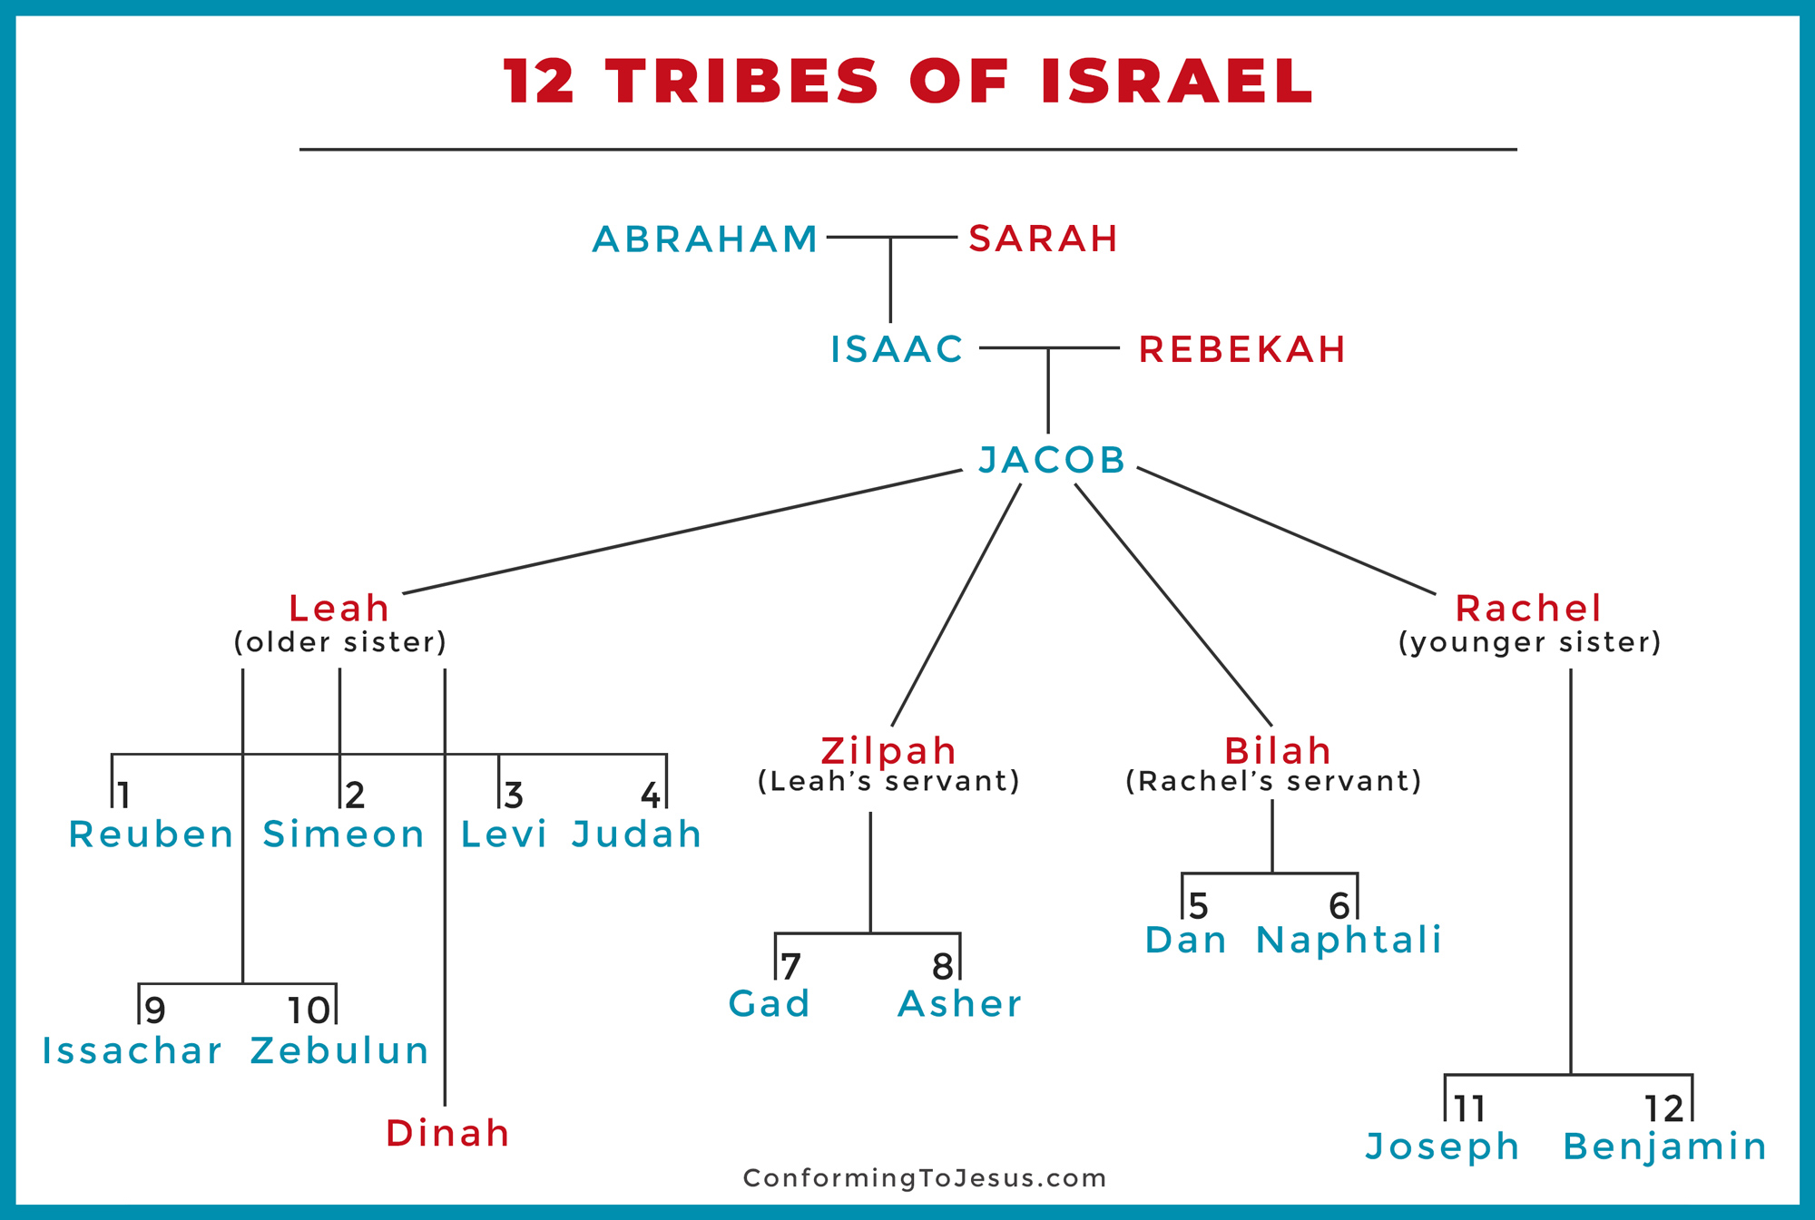
14 Now in the days of wheat harvest Reuben went and found mandrake fruits in the field, and brought them to his mother Leah. Then Rachel said to Leah, “Please give me some of your son’s mandrakes.” 15 But she said to her, “Is it a small matter for you to take my husband? And would you take my son’s mandrakes also?” So Rachel said, “Therefore he may sleep with you tonight in return for your son’s mandrakes.”
Reuben is Leah's firstborn son (Genesis 29:31–32). It's hard to tell from the chronology how old he is here. Some scholars suggest he may have been less than six years old at this time.

It's possible that Reuben was helping with the wheat harvest when he found these plants known as mandrakes. This perennial plant is thought to be of the mandragora family, with blue flowers and yellow fruit in season. Mandrakes were also thought, apparently, to be an aphrodisiac and perhaps an aid to infertility in women. It's possible that mandrakes were quite rare in this region at this time, making Reuben's discovery quite a find.

This discovery becomes contentious, because sisters Rachel and Leah are engaged in a bitter competition to produce children for their mutual husband, Jacob. Rachel has never herself given birth to children, instead obtaining hers using a cultural law which allowed her to claim the children of her servant, Bilhah (Genesis 30:1–8). Leah, for her part, has stopped conceiving after giving birth to four sons (Genesis 29:31–35). Their interest in these mandrake plants makes perfect sense given their desire to become pregnant, as well as their urge to corner Jacob's affection.

In any case, when Rachel sees or hears that Reuben has brought mandrake plants to his mother Leah, she asks if she can have some of them. Leah's reaction won't be especially polite, but it will reveal just how dysfunctional this family has become.

