The Patriarchs from the book of Genesis Part 26 – March 23, 2024
With input from https://www.bibleref.com/Genesis30; https://www.linkedin.com/posts/creolechemist-78809068_creolechemist-herb-of-the-day-mandrake-activity-7157723754641379328-1vm0/; Henry Morris The Genesis Record, page 474

Last time we ended with Rachel and Leah competing for the attention of their husband Jacob and the strong desire to have the most children when Ruben, as a child, found mandrake fruits in a field. Like a beet or carrot, this is a plant where the root was the edible part and mandrake allegedly had aphrodisiac and fertility properties.

Genesis 30:14 Now in the days of wheat harvest Reuben went and found mandrake fruits in the field, and brought them to his mother Leah. Then Rachel said to Leah, “Please give me some of your son’s mandrakes.”

Creole Chemist Brandon Williams: “Mandrake root (Mandragora officinarum) is a plant with a long history of folklore and mythology, often associated with mystical and magical properties. One of the legends surrounding mandrake is that its roots sometimes resemble human figures, leading to beliefs about its supernatural powers.

According to folklore, mandrake roots were believed to scream when pulled from the ground, and their human-like appearance added to the mystique surrounding the plant. The idea of mandrake roots resembling humans likely contributed to their association with various magical and ritual practices in ancient times.

Benefits: While mandrake has a long history of traditional use in various cultures for its purported medicinal properties, it's important to note that scientific evidence supporting its medicinal benefits is limited, and the plant can be toxic if ingested in large amounts. In folklore and traditional medicine, mandrake has been associated with aphrodisiac properties and fertility enhancement. However, these claims are not supported by scientific evidence.”

Perhaps with many old remedies and charms, correlation did not equal causation.

Then we find that Rachel had kept Jacob from sleeping with Leah in verse 15.

Genesis 30:15 But she said to her, “Is it a small matter for you to take my husband? And would you take my son’s mandrakes also?” So Rachel said, “Therefore he may sleep with you tonight in return for your son’s mandrakes.”

Her statement that Rachel has "taken my husband" in light of Rachel now giving permission for Jacob to “sleep with you” reveals to us that Jacob is likely no longer sleeping with Leah. His desire for Rachel has given her full control over his affection and attention. Leah has been left on her own.

Jacob again does not need to be told twice to engage in sex:

Genesis 30:16 When Jacob came in from the field in the evening, Leah went out to meet him and said, “You must have relations with me, for I have indeed hired you with my son’s mandrakes.” So he slept with her that night.

So, let’s catch up with the "birth race" between these two sisters. Leah has conceived four children of her own (Genesis 29:31–35), plus two more through her servant, Zilpah (Genesis 30:9–13). Rachel, on her part, has been infertile, but has obtained two children through her servant, Bilhah (Genesis 30:1–3).

17 God listened to Leah, and she conceived and bore Jacob a fifth son.

We're told in this verse that God listened to Leah. In other words, Leah had been asking God to give her more children with Jacob. Now God has answered her prayer. Despite the efforts of man, Genesis continues to insist that God is ultimately the one who gives children, not husbands or mandrake plants, or—as seen later in this chapter—striped sticks (Genesis 30:37–43).

18 Then Leah said, “God has given me my reward, because I gave my slave to my husband.” So she named him Issachar.

Leah names this son based on her understanding that God is repaying her for giving her servant Zilpah to Jacob as a wife. That seems to indicate that Leah saw this sharing of Zilpah with Jacob, even for the sake of having more sons, as a sacrificial act for the better good of Jacob. The name Yissaskar is similar to the word used in this verse for wages, sakar, so the name might also mean "my hire" or "man of hire," referring to the night with Jacob that Leah bought by giving her mandrake plants to Rachel. But to be clear the name may also mean "may God be gracious."

19 And Leah conceived again and bore a sixth son to Jacob. 20 Then Leah said, “God has endowed me with a good gift; finally my husband will acknowledge me as his wife, because I have borne him six sons.” So she named him Zebulun.

Now that she has born him a sixth child, Leah expresses her deep hope that perhaps her husband will at least "honor" or perhaps "live with" her, depending on the translation of the Hebrew word zabal.

She connects these two expressions, gratitude to God for this gift and confidence that her husband will honor her, with the name Zebulun. That name, Zabuwluwn in Hebrew, contains references to both "gift" and "honor."

21 Afterward she gave birth to a daughter, and named her Dinah.

Dinah will become a key character in the story of Jacob's family later on (Genesis 34). Though we're not told why Leah gave her the name, the Hebrew Diynah means "judgment" or "vindication." Her birth was one more piece of evidence that God had vindicated Leah, in spite of the fact that her own husband seemed to value her so little.

22 Then God remembered Rachel, and God listened to her and opened her womb.

Now Rachel's long years of waiting come to an end. A major theme of this chapter is exactly who gives the gift of children: God, and God alone. Personal schemes (Genesis 30:1–3), plants (Genesis 30:14–17), and even striped sticks, coming up in verses 37–43 are irrelevant, since it's God who holds the real power. Now, God "remembers" Rachel, a phrase which refers to God's favorable consideration. He opens her womb. The Bible is consistent from start to finish in teaching that God is the creator of life and the giver of children in all cases, but this teaching is a particular focus in the lives of Israel's early ancestors.

23 So she conceived and gave birth to a son, and said, “God has taken away my disgrace.” 24 And she named him Joseph, saying, “May the Lord give me another son.”
After years of infertility, and a bitter competition with her own sister, Rachel has finally given birth to a natural son of her own. As a result, Rachel expressed her faith that God had given this son to her as a gift. In doing so, she declared in the previous verse that God had taken away the shame she carried as a childless wife. That culture would have viewed barrenness as a shameful, embarrassing condition. Now Rachel gives her son a name that also serves as a prayer for yet another son. Joseph means, in part, "may God add." The Hebrew for this name, Yowceph, is related to the word used earlier in the verse for "taking away" her shame, ā'sap, as well as the word used for "giving" of a future son, yacaph.

Favoritism, unfortunately, runs in Jacob's family. His mother and father were very clear about which child they each preferred (Genesis 25:28). Rebekah's preference for Jacob inspired her to help Jacob cheat his brother, Esau, out of a blessing from their father, Isaac (Genesis 27:5–10). Since he never wanted to marry her in the first place, Jacob demonstrates a clear "hatred" for his first wife Leah, in comparison to her sister and his adored second wife, Rachel (Genesis 29:18–30). Rather than learning a lesson from these imbalances, Jacob will instead follow suit, lavishing his favor on Joseph to such an extent that it fuels jealous revenge in the hearts of his other sons (Genesis 37:3–4).

The birth of Joseph increases the number of Jacob's sons to 11. It also seems to be the event that turns Jacob's thoughts to moving back to his home in the promised land of Canaan. Now that his true love, and favored wife, has borne a son, Jacob probably feels that he is ready to return home, and to face his future.

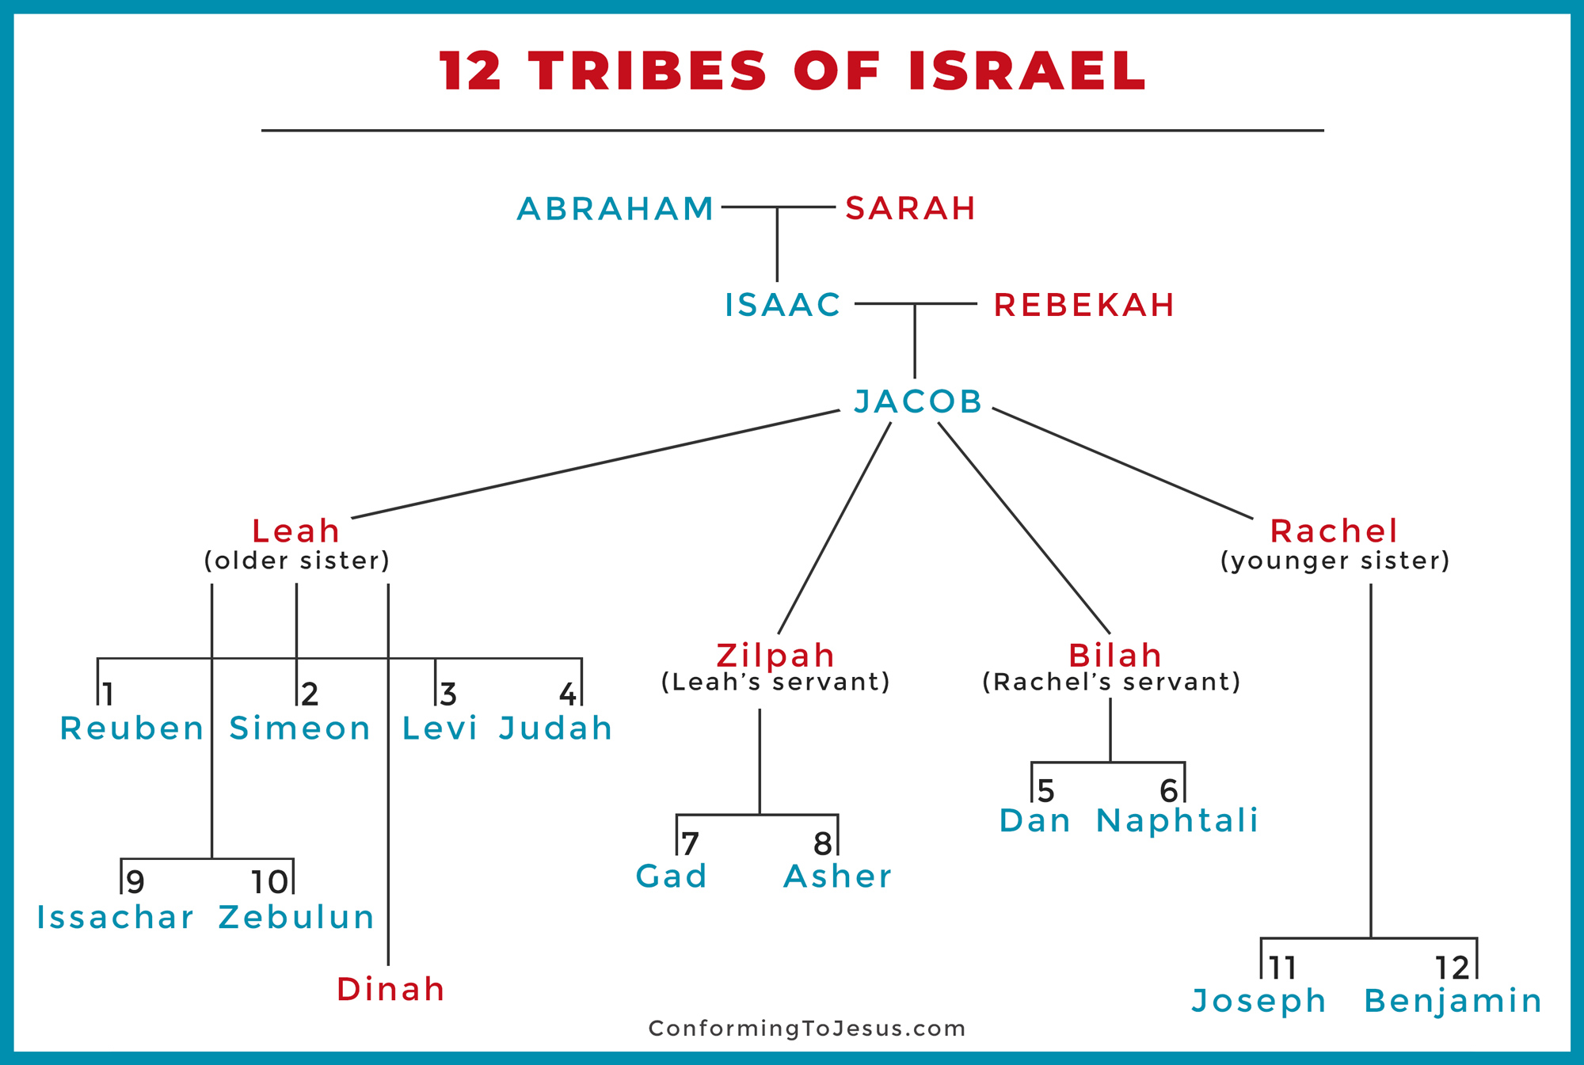

25 Now it came about, when Rachel had given birth to Joseph, that Jacob said to Laban, “Send me away, so that I may go to my own place and to my own country. 26 Give me my wives and my children for whom I have served you, and let me go; for you yourself know my service which I have rendered you.”

Jacob's agreed upon time of service to Laban is up. He has met his commitment to work for his father-in-law another seven years after marrying Leah and Rachel. Jacob is ready to take his expansive family and return to his homeland.

He began in the previous verse by saying to Laban, "Send me away." Now Jacob continues, "Give me."
The text seems to want us to catch that Jacob is taking a firm tone with Laban. He is aware that Laban will likely not want to lose Jacob's productivity or his closeness to his daughters and grandchildren. He is also aware that Laban can be tough and tricky when he wants something—and prone to outrageous levels of deceit.

Jacob states clearly that he has met the terms of their agreement. He also demands clearly that Laban give to him his wives and children in exchange for all of his service.

27 But Laban said to him, “If it pleases you at all, stay with me; I have determined by divination that the Lord has blessed me on your account.”

Laban's response here does not contain a yes or a no. Instead, he politely asks Jacob to stay. Laban reveals that he knows he is prospering because of the Lord's blessing of Jacob.

Scholars seem to disagree about exactly what is meant by Laban's statement about divination. It's possible that he looked for good omens or performed a ritual to determine the Lord's blessing. Or the language may simply mean that Laban "divined" the truth, figured it out, from the fact that he had grown so wealthy. In any case, Laban says he has a lot to lose, financially, if Jacob leaves.

28 He continued, “Name me your wages, and I will give them.”

Laban presents his refusal to let Jacob go as an opportunity for Jacob: "Name your price." In other words, Laban is proposing that he and Jacob strike a new deal now that Jacob has fulfilled the terms of the old one.

This is dangerous territory for Jacob: so far, every time he has negotiated a price for service with Laban, those deals have either ended in treachery, or a request for more service, as in this verse.

29 But Jacob said to him, “You yourself know how I have served you and how your livestock have fared with me. 30 For you had little before I came, and it has increased to a multitude, and the Lord has blessed you wherever I turned. But now, when shall I provide for my own household also?”

Jacob reminds his father-in-law that before Jacob arrived, he had little. Laban has already said that he knows this is true. It's why he doesn't want Jacob to leave. Because of the Lord's blessing on Jacob, Laban was able to prosper—helped in no small part by Laban's own treachery (Genesis 29:18–30).

Whatever comes next, both of these men clearly understand that Laban's wealth and Jacob's success with the livestock are the result of God's blessing, and a blessing on Jacob in particular. Whatever their motives, both men are negotiating from a position of faith in God's power and His faithfulness to keep His promises to Jacob.

31 So he said, “What shall I give you?” And Jacob said, “You shall not give me anything. If you will do this one thing for me, I will again pasture and keep your flock: 32 let me pass through your entire flock today, removing from there every speckled or spotted sheep and every black sheep among the lambs, and the spotted or speckled among the goats; and those shall be my wages.

Instead of insisting on leaving right away, Jacob has come up with a plan to gain some wealth for himself. He is aware that Laban is a tough—and deceptive (Genesis 29:18–30)—negotiator. He is also counting on the fact that the Lord will continue to bless him abundantly.

Laban asks again: What do you want from me? Jacob surprises him with a tricky answer of his own: Don't give me anything right now. Instead, Jacob will ask for a specific cut of the future profits in the following verses. Laban, predictably, will respond by trying to cheat Jacob.

Jacob asks that any future black lambs or speckled and spotted sheep and goats be his payment. Apparently, most of the sheep in a flock were white all over, and most of the goats were entirely black. In essence, Jacob is asking for a seemingly small subset of the animals. As the following verses will reveal, Jacob believed he could produce a lot of these spotted and speckled animals with selective breeding (Genesis 30:37–39). Much later, Jacob will reveal his knowledge that God, not strange farming practices, is the real source of the animals' growth (Genesis 31:10–13).

Laban, ever greedy and unfair, will hatch his own plan to try to keep Jacob's take of the flock small.

33 So my honesty will answer for me later, when you come concerning my wages. Every one that is not speckled or spotted among the goats, or black among the lambs, if found with me, will be considered stolen.”

Now Jacob insists that this will keep things honest between them. After all, if Jacob's personal flocks contain any all–white sheep or all–black goats, they will stand out as ones which should belong to Laban, and can be considered stolen.

34 Laban said, “Good, let it be according to your word.” 35 So he removed on that day the striped or spotted male goats, and all the speckled or spotted female goats, every one with white on it, and all the black ones among the sheep, and put them in the care of his sons. 36 And he put a distance of three days’ journey between himself and Jacob, and Jacob fed the rest of Laban’s flocks.

Laban immediately finds a way to cheat. The agreement between Laban and Jacob was that Jacob would own every black sheep and mixed-color sheep or goat born among the flocks from this time forward. Fully white sheep and fully black goats were far more common, so the deal was already tipped in Laban's favor. Jacob is asking to only keep the uncommon, "defective" animals. At least in theory, Laban again stands to gain a great deal from this arrangement.

And yet, to improve his odds even more, Laban now acts to remove all of the mixed-color animals and black sheep from the existing herds and gives those to his sons. Spotted and speckled sheep and goats are mostly likely to be born to spotted and speckled parents. If Laban were to remove all of those at the start, only a very small percentage born in the remaining flock—if any—were likely to be black lambs or mixed-color sheep or goats. This is a cheat designed to turn Jacob's own plan against him. To further drive home his plan, Laban will also move these animals several days' journey away from Jacob.

37 Then Jacob took fresh rods of poplar, almond, and plane trees, and peeled white stripes in them, exposing the white that was in the rods. 38 He set the rods which he had peeled in front of the flocks in the drinking troughs, that is, in the watering channels where the flocks came to drink; and they mated when they came to drink. 39 So the flocks mated by the rods, and the flocks delivered striped, speckled, and spotted offspring.

Let’s jump ahead to Genesis 31:4–12 to get a clear understanding of what is happening:

4 So Jacob sent word and called Rachel and Leah to his flock in the field, 5 and said to them, “I see your father’s attitude, that it is not friendly toward me as it was before, but the God of my father has been with me. 6 You know that I have served your father with all my strength. 7 Yet your father has cheated me and changed my wages ten times; however, God did not allow him to do me harm. 8 If he said this: ‘The speckled shall be your wages,’ then all the flock delivered speckled; and if he said this: ‘The striped shall be your wages,’ then all the flock delivered striped. 9 So God has taken away your father’s livestock and given them to me.

10 And it came about at the time when the flock was breeding that I raised my eyes and saw in a dream—and behold—the male goats that were mating were striped, speckled, or mottled. 11 Then the angel of God said to me in the dream, ‘Jacob’; and I said, ‘Here I am.’ 12 He said, ‘Now raise your eyes and see that all the male goats that are mating are striped, speckled, or mottled; for I have seen everything that Laban has been doing to you.

Jacob's plan to claim all the spotted/speckled sheep and goats came from God. How he executes this plan may sound like some kind of folk magic, but it is the process by which God supernaturally blesses Jacob's efforts to get more black sheep and mixed-color animals.

Jacob takes sticks fresh from three specific kinds of trees and strips the bark to reveal the white underneath. This is, in part, a play on words: the Hebrew term for "white" is laban. With God's supernatural blessing, Jacob will use these sticks to influence how many striped, spotted, and speckled animals are born.

Henry Morris:
Jacob knew a great deal about sheep and goats and cattle, much more than Laban. He had kept his father’s flocks for decades, and Laban’s for 14 years. He had apparently learned something of what we now call Mendelian genetics, simply by long-continued observation of these animals. He knew that even though a species of animal may have certain dominant traits (such as the white color in this type of sheep) there are, in each generation, certain individual animals that manifest one or more “recessive” traits (such as the brown color among the sheep). Furthermore, actual physical vigor and usefulness for man’s needs are quite independent of this matter of coloration. He believed that he could simply trust God to increase the statistical proportion of animals in future generations of Laban’s flocks that would appear with these recessive traits.

It is important for us to notice that despite Jacob’s past and current actions, God makes the promise to bless Jacob and then God keeps that promise. This same principle exists for us today. God made the promise in Hebrews 13:5-6: Keep your life free from love of money, and be content with what you have, for he has said, “I will never leave you nor forsake you.” 6 So we can confidently say,

“The Lord is my helper; I will not fear; what can man do to me?”

